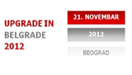
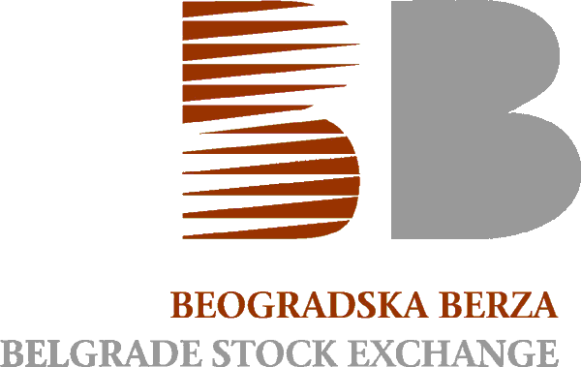
PRESS RELEASE

11th INTERNATIONAL CONFERENCE
OF THE BELGRADE STOCK EXCHANGE
- UPGRADE IN BELGRADE -

On Wednesday, November 21 in Belgrade Hotel Tulip Inn Putnik the traditional 11th International Conference of the Belgrade Stock Exchange - UPGRADE IN BELGRADE 2012 was held. The Conference was attended by over 150 local and international professionals in the field of capital markets and financial operations, and the central themes were the perspective of debt securities in the domestic capital market and the possibility of the first initial public offering (IPO) in Serbia.

Recently completed primary trading in debt securities of the Erste Bank on Belgrade SE and anticipated including of the municipal bonds to the market prompted a discussion on the possible impact of various forms of debt securities on reviving domestic capital market, but also about the effects that issuers of these securities may expect from transfering from bank borrowing to the debt securities financing. Common position of the Conference participants was that for the future efficiant development of the securities market and spread of it's positive effects to the overall capital market the development of the primary and secondary debt markets should necessary be synchronized, as well as that the greater involvement of all relevant institutions in promoting and facilitating the process of borrowing via the capital market and also broadening the base of issuers and investors in debt securities.

Regarding the possibility of the realization of the first initial public offering (IPO) in the domestic capital market discussion at the Conference took place in two directions: on the one hand, the experiences of developed European markets were presented, while, at the same time the most important issues that need to be resolved in order to advance the realization of a successful public offering in the local market were tackled. From the point of view of companies that might opted for an IPO the importance of planning the activities, ranging from legal and accounting requirements to the internal management's readiness to open a company and promote long-term sustainable business were emphasized. In the context of the development of the national market the need for additional incentives by regulatory authorities has reinforced along with the education process and the suggest that the future initial public offerings of companies should be organized on the local market before going international.

Conference participants in particular stressed the fact that the IPO is not a solution only for large corporations, but with an appropriate measures of the State and other market institutions, might successfully help overcome the pervasive problem of financing small and medium enterprises. Apart from the IPO panel, the topic about financing small and medium-sized enterprises and start-up companies from a wide range of industries, was covered separately in the special lecture on the topic: " Breaking down the Barriers - developing private equity and venture capital in Serbia." After inclusion of venture capital and private equity investors in the company during it’s development, one of the available effective exit strategies is IPO.

In the separate part of the Conference - a panel discussion on the topic: " The Crisis of Economy and Politics" leading national experts gave an overview of the current state of the Serbian economy, dependance of the economic development on the events in the local political scene, and expectations for the future. A special display of interdependence of the capital market development and the economic and political environment was presented from the perspective of direct participants in the market, analysts and media representatives.

BEST IR AWARD FOR 2012

For the third time in a row at the 11th International conference of the Belgrade SE the prize was awarded to a company that, according to a survey by the IR Commission and the poll on the website of the Belgrade SE, in the current year achieved the best results in investor relations. As in previous years, this year the company that received a plaque was NIS a.d. Novi Sad, whose reporting in the field of investor relations respect the highest international standards. Special Award for the high quality of relationships with investors in previous years, this year was presented to representatives of Metalac a.d. Gornji Milanovac.

THE FIFTH ANNIVERSARY OF FIRST LISTINGS ON THE PRIME LISTING

The fifth anniversary of first Listings on the Prime Listing on the Belgrade SE was celebrated at the 11th International Conference of the Belgrade SE. On this occasion, representatives of the companies whose shares were listed in year 2007: Tigar a.d. Pirot, Energoprojekt a.d. Beograd and Soja Protein a.d. Bečej presented their experiences and review about listing on the Belgrade SE.

----------------------------------------------------------------------------------------------------------

UPGRADE IN BELGRADE
INTERNATIONAL CONFERENCE OF THE BELGRADE SE

Since 2002, the Belgrade Stock Exchange has organized its annual international conference, which is one of the largest and widely attended regional gatherings of representatives of domestic and foreign capital markets.

In addition to currently important issues, the presentations are intended to introduce new topics, insufficiently present in the region. The conference is attended by representatives of the government, regulatory bodies, scientific institutions and domestic broker and fund industry, as well as representatives of the neighbouring markets and regulatory bodies, institutions, professional associations and other stock exchanges from Europe and USA.

More information about the participants and speakers of this year Conference, as well as previous Conferences of the Belgrade SE and available presentations are posted on the website of 11th International Conference Exchange http://www.belex.rs/k12/index_e.php.
