

Based on Art. 65 of the Law on the Capital Market (RS Official Gazette No. 31/2011) and Art. 6 and 7 of the Regulation on the reporting requirements for public companies and notification requirements for voting shares held in possession (RS Official Gazette No. 100/06 and 116/06), Energoprojekt Holding p.l.c. from Belgrade, Bulevar M. Pupina 12 (ID number: 07023014, Business code: 06420 Holding business) presents this:

REPORT OF A SIGNIFICANT EVENT
(Invitation to resume for the second time the XXXVII Extraordinary General Meeting of Energoprojekt Holding p.l.c.)

As you are aware, the XXXVII extraordinary general meeting of Energoprojekt Holding p.l.c. was suspended on 14/12/2011 on the basis of Art. 19 par. 1 line 2 of the GM Rules of Procedure, because during the meeting the number of shareholders present, or their proxies, fell below the required minimum for decisions to be valid.

Subsequently, the Board of Directors of Energoprojekt Holding p.l.c. in keeping with the provisions of Art. 23, par. 5 of the Articles of Association of Energoprojekt Holding p.l.c., scheduled a resumption of the suspended XXXVII extraordinary general meeting for 27/12/2011.

As the number of shareholders and proxies in attendance at the resumed XXXVII extraordinary general meeting was less than the required minimum according to Art. 23 par. 1 of the Articles of Association, the meeting could not be properly convened and the remaining items of the agenda therefore were not deliberated.

***
In light of the above circumstances and the relevant provisions of the Companies Law and the Holding’s Articles of Association, having considered the proposals of the Executive Board and Managing Director of Energoprojekt Holding p.l.c., and the official opinion of the relevant departments of Energoprojekt Holding p.l.c., in accordance with the powers granted under Art. 23 par. 5 in reference to par. 3 of the Articles of Association of Energoprojekt Holding, in keeping with the resolution taken at the 10th board meeting held on 28/12/2011, the Board of Directors schedules this

SECOND RESUMPTION

OF THE XXXVII EXTRAORDINARY GENERAL MEETING OF
ENERGOPROJEKT HOLDING p.l.c.
to be held on Thursday, 12 January 2012
at the Great Hall of the Labour Union Center (Dom sindikata) at 9:00 AM

The Board of Directors of Energoprojekt Holding p.l.c. resolves that remaining to be addressed at the XXXVII extraordinary general meeting are the following items of the

AGENDA

3.2. ADOPTION OF ARTICLES OF ASSOCIATION OF ENERGOPROJEKT HOLDING P.L.C.
(Reported presented by: Holding BoD)

  - ADOPTION OF RULES OF PROCEDURE FOR THE GENERAL MEETING OF ENERGOPROJEKT HOLDING P.L.C.

(Reported presented by: Holding BoD)

The Board of Directors of Energoprojekt Holding p.l.c. resolves pursuant to Art. 23 par. 3 of the Articles of Association that the required minimum number of shareholders and proxies in attendance at the second resumption of the XXXVII extraordinary general meeting is 1/3 of the total number of shares with right to vote on items of the above agenda.

CHAIRMAN OF THE BOARD
ENERGOPROJEKT HOLDING P.L.C.
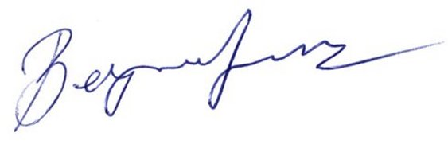
Ivar Berger, LLB

