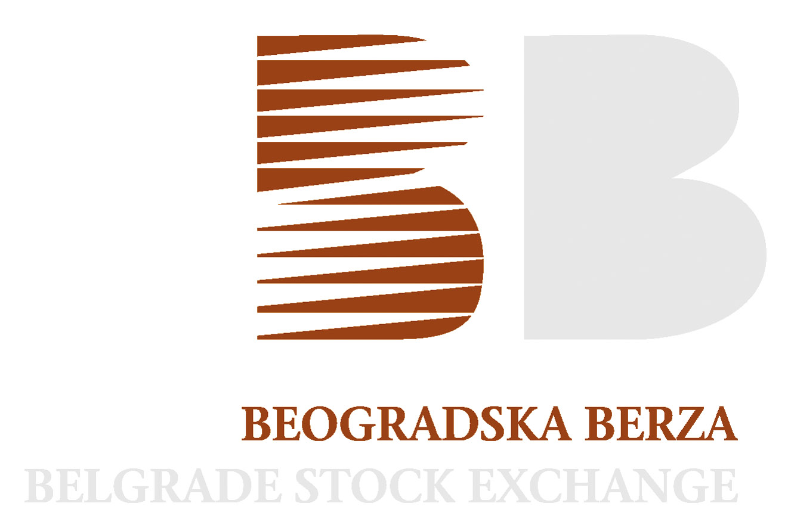

Belgrade, 8 November 2010

PRESS RELEASE

Belgrade Stock Exchange: SEE Regional Capital Markets Conference of Raiffeisen Centrobank AG and South-Eastern European Stock Exchanges
- 21 listed companies from eight South-Eastern European countries
- 170 one-on-ones with Austrian and international investors

The strong interest that South-Eastern European (SEE) companies have in building up contacts with investors was reason enough for Raiffeisen Centrobank and stock exchanges from the region to organize the SEE Regional Capital Markets Conference. The Conference will be held in Hotel Sacher in Vienna, on Noveber 9th. The stock exchanges of Belgrade, Ljubljana, Zagreb, Skopje, Sarajevo, Banja Luka, Podgorica, Sofia and Bucharest were among the South-Eastern European cooperation partners of the Raiffeisen Centrobank. Around 65 Austrian and international investors and 21 listed companies will take part in the event.

With this conference, the Equity House of the Raiffeisen Bank International Group offers international corporations a platform that facilitates intensive communication with clients. “We have recognised in time the opportunities in the SEE area and further intensified our activities within the region”, explains Michael Spiss, CEO of Raiffeisen Centrobank. The total of 21 listed companies from the SEE region who accepted the investment bank's invitation is a new record this year. Around 170 one-on-ones with a competent investor community reflected the significant interest in the required flow of information.

The companies from the Belgrade Stock Exchange that will answer investors' questions at the conference are: Construction company Energoprojekt holding, food producer Sojaprotein, rubber producer Tigar and the bank Komercijalna Banka.

For more information about this event, please contact Marketing department of the Belgrade Stock Exchange, e-mail: marketing@belex.rs

