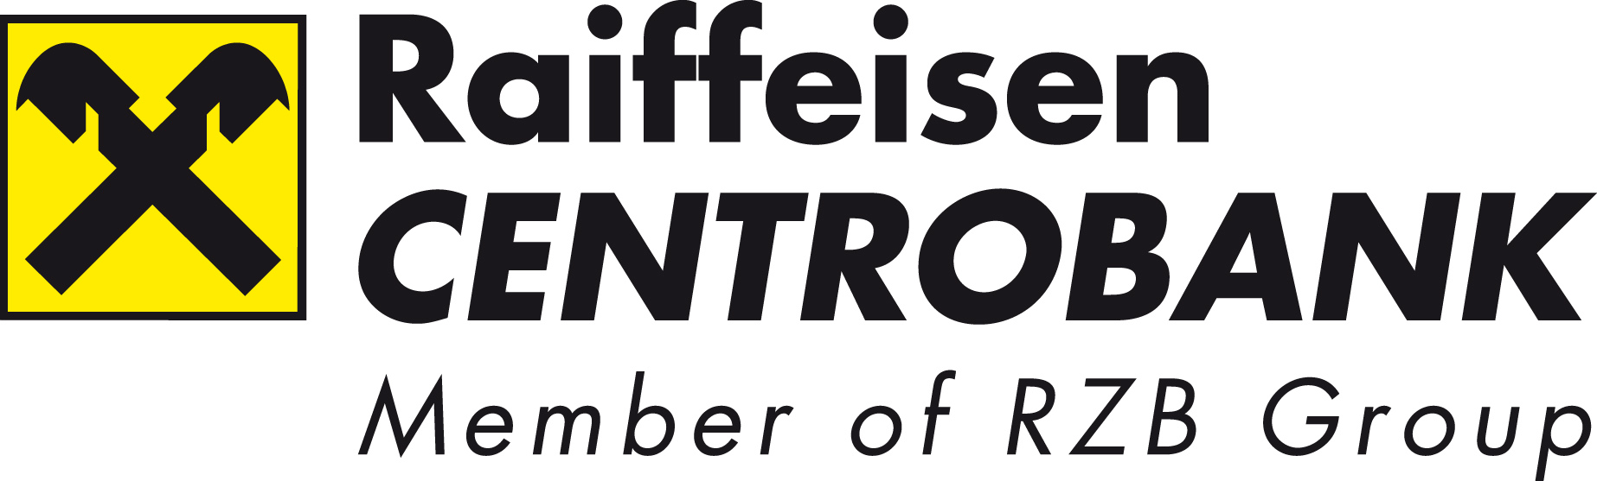

Vienna, 4 November 2009

PRESS RELEASE

Raiffeisen Centrobank organises SEE Regional Capital Markets Conference together with Belgrade Stock Exchange and in cooperation with Ljubljana Stock Exchange, Zagreb Stock Exchange, Sarajevo Stock Exchange, Banja Luka Stock Exchange, Montenegro Stock Exchange, NEX Stock Exchange and Macedonian Stock Exchange.
19 South-Eastern European listed companies will join the SEE conference, 100 one-on-ones with Austrian and international investors are organized

Vienna: Raiffeisen Centrobank AG invites together with the Belgrade Stock Exchange investors and companies to the Hotel Sacher in Vienna for the SEE Regional Capital Markets Conference. Other cooperation partners in South-Eastern Europe are: Macedonian Stock Exchange, Ljubljana Stock Exchange, Zagreb Stock Exchange, Banja Luka Stock Exchange, Montenegro Stock Exchange, Nex Stock Exchange and Sarajevo Stock Exchange. 50 Austrian and international investors will attend this event.

“The gentle recovery of the capital market is causing a significant rise in the interest expressed by institutional investors in a more intensive flow of information. We are therefore offering our customers a platform to enable a more intensive communication,” says Michael Spiss, member of the executive board of Raiffeisen Centrobank, which is holding this event. A total of 19 listed companies from the SEE region have accepted the invitation and are taking the opportunity to present themselves to the competent investor community. 100 one-on-ones are planned during the conference.

Eastern European competence
Raiffeisen Centrobank identified the opportunities in the SEE region very early and through his strong Eastern European network it became the regional market leader in investment banking in recent years. “We were already a leader in numerous successful privatisations and IPOs in South-Eastern Europe. Using alliances, we will be able to expand our strong SEE network even in the future,” explains Spiss.

Listed companies
The companies from the following countries will face investors' questions at the conference:

Croatia: Consulting company Institut IGH, telecommunications company Ericsson Nikola Tesla, cosmetics manufacturer Atlantic Grupa and telecommunications company HT-hrvatske telekomunikacije.
Serbia: Construction company Energoprojekt holding, soya bean processor Sojaprotein, tyre producer Tigar and the bank Komercijalna Banka Beograd.
Slovenia: Retail chain Poslovni sistem Mercator, insurance company Zavarovalnica Triglav, credit bank Nova KBM and telecommunications company Telekom Slovenije.
Macedonia: Pharmaceutical producer Alkaloid, the bank Komercijalna Banka Skopje and construction company Granit.
Bosnia and Herzegovina: Food producer Klas and telecommunications company Telekom Srpske.
Montenegro: The Montenegrin wine producer 13. jul. Plantaze and telecommunications company Crnogorski Telekom.

Further information about Raiffeisen Centrobank can be found at http://www.rcb.at<0}

Press inquiries: {Mag. Karin Keglevich
Special Public Affairs PR-Beratung & Lobbying GmbH
Goldschmiedgasse 8/8, 1010 Vienna
Tel +43 1 532 25 45 10, mobile: } +43 664 3380834
E-mail: keglevich@spa.co.at

