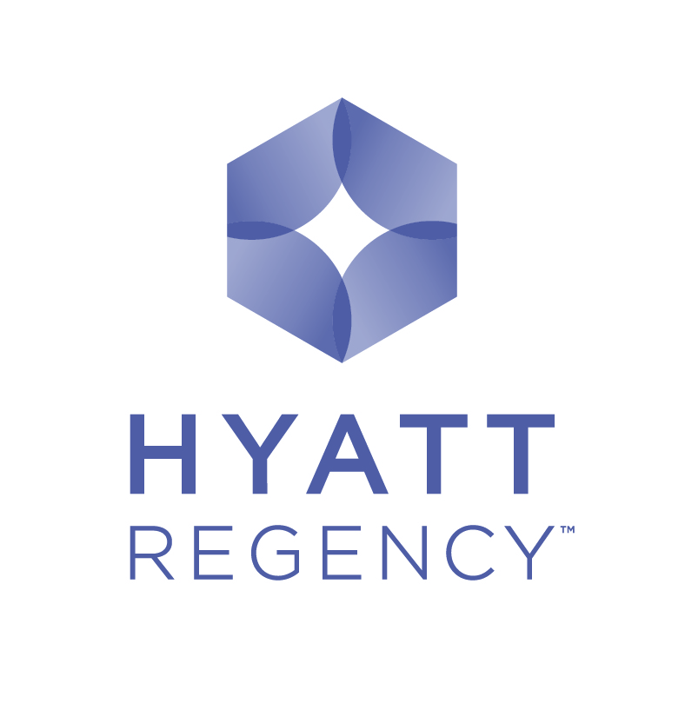

Reservation Form
Hyatt Regency Belgrade looks forward to having you as a guest during the

“17th International Conference”

(Belgrade, November 14-16, 2018)
Hotel Hyatt Regency Belgrade

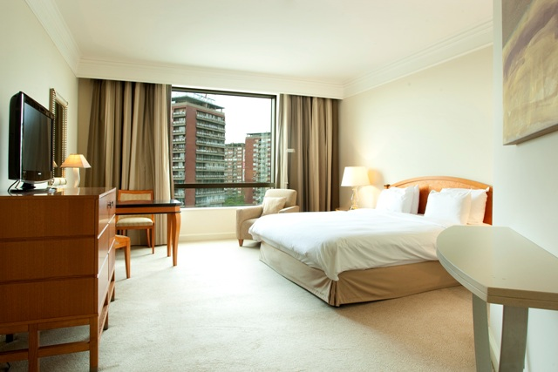
This reservation form should be used to secure a room. Should you require a room outside the dates, hotel’s Reservations Department will advise you of availability and rates. Listed below are the current best prices for accommodation. Number of rooms under bellow proposed special rate is limited. Please note that all filled in reservation forms will be accepted subject to availability. Deadline date is 14.10.2018.

Room requirements (please tick)

King / Twin Room (38sqm) 105 EUR single / 120 EUR double occupancy

Regency Club King / Twin Room (38sqm) 150 EUR single / 165 EUR double occupancy

Rates are per night including breakfast and internet, excluding VAT (10%) and tourist tax 155 RSD (EUR 1,5 p.p.). Note that VAT and tourist tax amount is subject to change. Supplement for third person in the room is EUR 15.
For all guest accommodated parking and use of the Olympus Fitness Club (swimming pool, sauna, gym and whirlpool) is complimentary.

Name: Company: Position/Title:
Address: City: Post Code:
Country: Telephone: Fax:
E-mail:

Credit card number:
Expiration date: Signature:

Arrival & Departure
Arrival Date: Departure Date:
(Check-In Time after 15:00) (Check-Out Time before 12:00)

Reservations are only acceptable by sending this form completed to Hotel reservation department (contact details listed bellow). No reservations will be confirmed nor guaranteed unless credit card details are supplied.
Hyatt chain is fully in compliance with Payment Card Industry standards, due to which we kindly ask you to provide your credit card information by telephone after sending this reservation form or completing the authorization form attached.

Cancellation period is 15 days prior to arrival. No-show/late cancellation fee is one night room rate.

Airport Pick-up / Drop-off
Airport transfer is available by hotel car at EUR 27 per way, per car. Should you wish to make a reservation of hotel’s car, please fill in the following details:
Arrival Flight Details: Departure Flight Details:

Please send this form to the attention of: For hotel Use

Hyatt Regency Belgrade Confirmation Number:
Reservation Department
Milentija Popovica 5, 11000 Belgrade, Serbia ROOM BLOCK: AWTW
Telephone: (381) (11) 301-1234 Comments: _____________________________
Fax: (381) (11) 311-2234 ________________________________________
E-mail: reserve.hrbelgrade@hyatt.com
Please note that any changes made to your reservation have to be notified in writing to the hotel.

